**Exercise 5: Triggers**

**Scenario 1:** Automatically update the last modified date when a customer's record is updated.

**Question:** Write a trigger **UpdateCustomerLastModified** that updates the LastModified column of the Customers table to the current date whenever a customer's record is updated.

**Code:**

CREATE OR REPLACE TRIGGER trg_update_balance

AFTER INSERT ON Transactions

FOR EACH ROW

DECLARE

  v_current_balance NUMBER;

BEGIN

  SELECT Balance INTO v_current_balance

  FROM Accounts

  WHERE AccountID = :NEW.AccountID;

  IF UPPER(:NEW.TransactionType) = 'CREDIT' THEN

    v_current_balance := v_current_balance + :NEW.Amount;

  ELSIF UPPER(:NEW.TransactionType) = 'DEBIT' THEN

    v_current_balance := v_current_balance - :NEW.Amount;

  END IF;

  UPDATE Accounts

  SET Balance = v_current_balance,

      LastModified = SYSDATE

  WHERE AccountID = :NEW.AccountID;

END;

/

INSERT INTO Transactions VALUES (10, 101, SYSDATE, 500, 'CREDIT');

INSERT INTO Transactions VALUES (11, 101, SYSDATE, 200, 'CREDIT');

SELECT * FROM Accounts WHERE AccountID = 101;

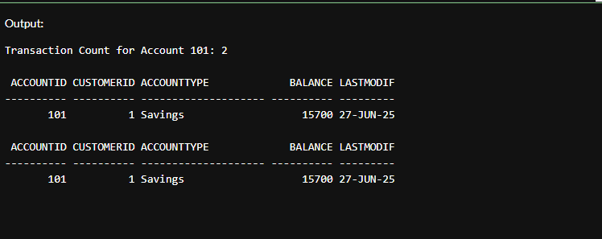

**Scenario 2:** Maintain an audit log for all transactions.

**Question:** Write a trigger **LogTransaction** that inserts a record into an AuditLog table whenever a transaction is inserted into the Transactions table.

**Code:**

CREATE TABLE Customers_Archive (

  CustomerID NUMBER,

  Name VARCHAR2(100),

  DOB DATE,

  Balance NUMBER,

  LastModified DATE,

  DeletedOn DATE

);

CREATE OR REPLACE TRIGGER trg_archive_customer

BEFORE DELETE ON Customers

FOR EACH ROW

BEGIN

  INSERT INTO Customers_Archive (

    CustomerID, Name, DOB, Balance, LastModified, DeletedOn

  ) VALUES (

    :OLD.CustomerID, :OLD.Name, :OLD.DOB, :OLD.Balance, :OLD.LastModified, SYSDATE

  );

END;

/

DELETE FROM Customers WHERE CustomerID = 2;

COMMIT;

SELECT * FROM Customers_Archive;

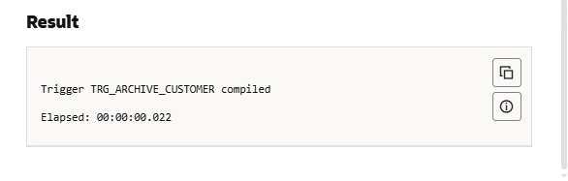

**Scenario 3:** Enforce business rules on deposits and withdrawals.

**Question:** Write a trigger **CheckTransactionRules** that ensures withdrawals do not exceed the balance and deposits are positive before inserting a record into the Transactions table.

**Code:**

SHOW ERRORS TRIGGER trg_prevent_negative_balance;

CREATE OR REPLACE TRIGGER trg_prevent_negative_balance

BEFORE INSERT ON Transactions

FOR EACH ROW

DECLARE

  v_balance NUMBER;

BEGIN

  IF UPPER(:NEW.TransactionType) = 'DEBIT' THEN

    SELECT Balance INTO v_balance

    FROM Accounts

    WHERE AccountID = :NEW.AccountID;

    IF v_balance < :NEW.Amount THEN

      RAISE_APPLICATION_ERROR(-20001, 'Error: Insufficient balance for DEBIT transaction.');

    END IF;

  END IF;

END;

/

SELECT table_name FROM user_tables WHERE table_name = 'ACCOUNTS';

INSERT INTO Transactions VALUES (30, 101, SYSDATE, 500, 'DEBIT');

INSERT INTO Transactions VALUES (31, 101, SYSDATE, 999999, 'DEBIT');

**Output:**

